SYSTEM ANALYSIS AND

DESIGN

UNIT – 1

System Study and System Development Life Cycle

Shree M. & N. Virani Science College (Autonomous)

ATMIYA Group of Institutions, Yogidham Gurukul, Rajkot.

Priyank Doshi

Asst. Professor (MCA, MSc.(Math) )



Computer Based Information System

.

.

.

System can be differentiated by manual or automated.

Manual system has been introduced from many centuries.

For example - Trading between different countries, banking were

already coming from very long time.

.

.

Functioning of all these is possible only by implementation of a

particular system.

After computer has been invented all these converted to

Computer Based Information System.

Shree M. & N. Virani Science College (Autonomous)

ATMIYA Group of Institutions, Yogidham Gurukul, Rajkot.

Priyank Doshi

Asst. Professor (MCA, MSc.(Math) )



TPS

Data

&

Application

Program

OAS

DSS

DSS

MIS

MIS

TPS

OAS

Shree M. & N. Virani Science College (Autonomous)

ATMIYA Group of Institutions, Yogidham Gurukul, Rajkot.

Priyank Doshi

Asst. Professor (MCA, MSc.(Math) )

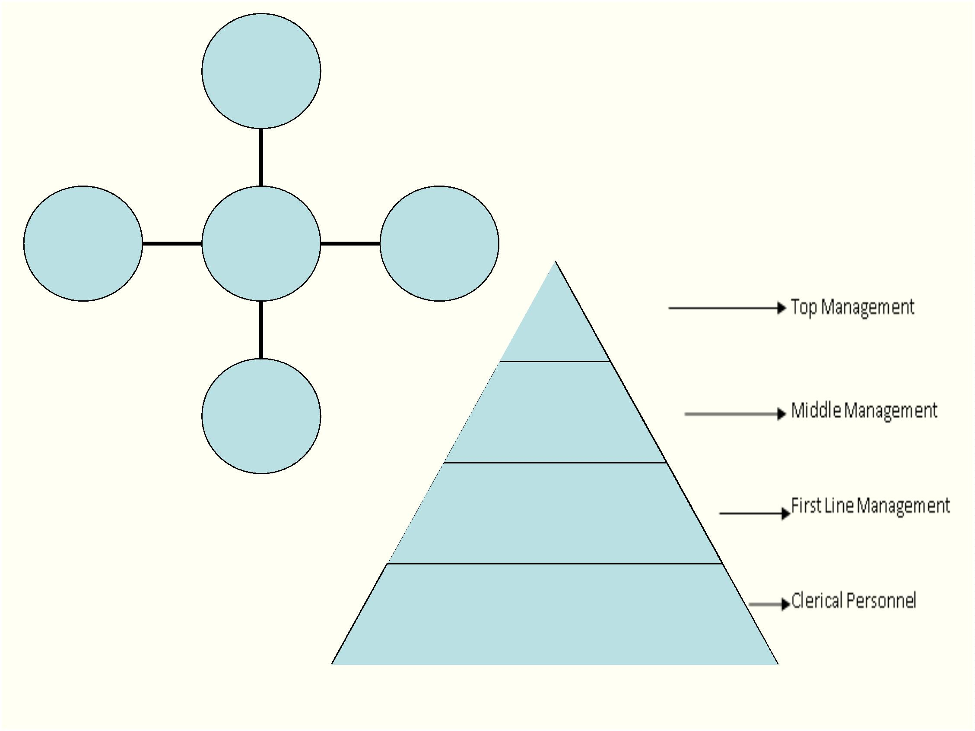

Why System Projects?

.

.

.

.

What is the role of computers in the business?

What are the benefits of using software in the Business system?

What are the reasons of project proposal ?

Why system projects?

Shree M. & N. Virani Science College (Autonomous)

ATMIYA Group of Institutions, Yogidham Gurukul, Rajkot.

Priyank Doshi

Asst. Professor (MCA, MSc.(Math) )



Why system projects? (Benefits)

.

Capability

. Communication

.

.

.

Improved processing speed

. Enhanced communication

. Integration of business areas

Increased volume

Faster retrieval of information

.

.

Cost

.

Control

.

Monitor costs (Tracking all type

of costs)

.

Greater accuracy and

consistency

. Reduce costs

.

Better security

Competitiveness

.

.

.

Lock in customers

Lock out competitors

Improve arrangements with

suppliers

.

New product development

Shree M. & N. Virani Science College (Autonomous)

ATMIYA Group of Institutions, Yogidham Gurukul, Rajkot.

Priyank Doshi

Asst. Professor (MCA, MSc.(Math) )



System Development Life Cycle

(Activities and Outcomes of Each Phase)

Shree M. & N. Virani Science College (Autonomous)

Priyank Doshi

Asst. Professor (MCA, MSc.(Math) )

ATMIYA Group of Institutions, Yogidham Gurukul, Rajkot.

